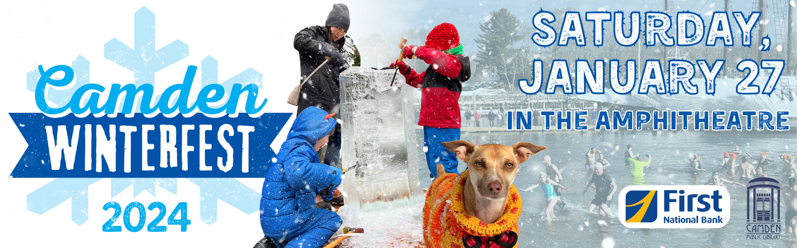

Ice Carving Team Application & Registration Form
Winterfest 2024 Community Ice Carving Event
Camden Amphitheatre

Date: Saturday, January 27, 2024
Time: 11:00 am – 2:00 pm Teams arrive between 10:00 am and 11:00 am

Name of Team / Organization: _________________________________________________________________________________________
Carving Team Captain’s Name: ________________________________________________________________________________________
Email Address: _________________________________________________________________________________________________________
Mailing Address: ________________________________________________________________________________________________________
Phone: ___________________________________________________________________________________________________________________
Website: _________________________________________________________________________________________________________________
How many team members intend to participate? ____________________________________________________________________
Entry Fee: Team entry fee is $60, which helps cover the cost of the 300 lb. block of ice.
Please include a check for $60 made payable to Camden Public Library with a notation reading “Ice Team Entry Fee, Winterfest” and Your Team Name.
_______ $60 entry fee enclosed.
_______ Raising entry fee; check will be sent separately.

Applicant Signature: ________________________________________________________ Date: ______________
There are a limited number of ice blocks available, so send your application as soon as you can.
Mail, email, or deliver your registration and check by Friday, January 12 to:
Julia Sagaser, Winterfest, Camden Public Library, 55 Main Street, Camden, ME 04843
This form can be filled out electronically and emailed to jsagaser@librarycamden.org.
For more information, call 236-3440.

